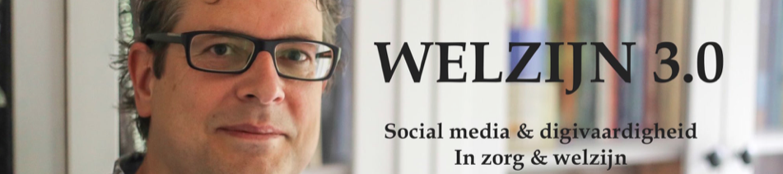

Pleas fill in this content matrix with short and first thoughts (those with a star are important)

My organization | My field of interest | My specialty * | Local activities | My personal interests* | The pain my clients feel * | My inspiration
name | Field | Specialism | Events | The human behind the profession | You help them with .. | How are you being informed
Field | Actuality | My clients | Hotspots | Spare time | What do they encounter | Your newspaper
Mission statement | Developments | Your project | Regional | Passion for | Consequences | Magazines
Vision | Past / now | Your expertise | Language | Your dream | Clients benefit from | websites
Service | In the news | Your goals | Nearby | Your family | Most dangerous | social media accounts
Colleagues | Future | Your achievements | Politics | Holidays | Most positive | podcasts
Welzijn 3.0, www.welzijn30.nl, info@welzijn30.nl, Hans Versteegh

